Name: Simão Fernando

Student Number:ST10459259

**HAWI**

**IMAD5112 Practicum**

**10 JUN 2024**

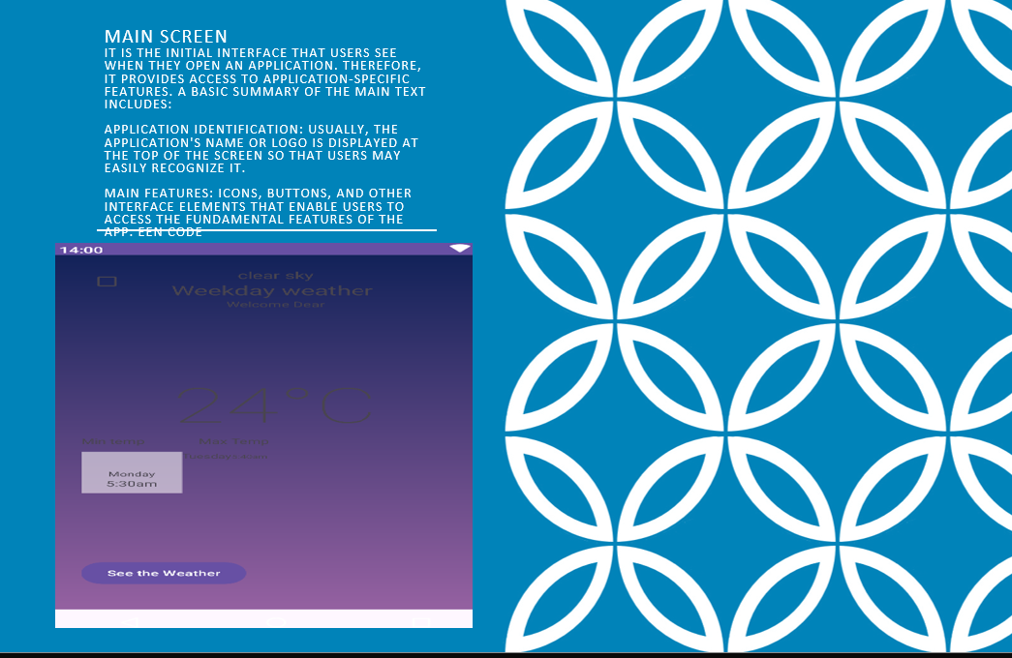

**Main Screen**  
It is the initial interface that users see when they open an application. Therefore, it provides access to application-specific features. A basic summary of the main text includes:  
  
Application Identification: Usually, the application's name or logo is displayed at the top of the screen so that users may easily recognize it.  
  
Main features: Icons, buttons, and other interface elements that enable users to access the fundamental features of the app.

**Linear Layout**  
The Linear Layout is a View Group on Android that arranges its children in a single direction, horizontal or vertical, according to the orientation you set. It is used to create simple and efficient layouts where components are laid out in a straight line, one after the other. This is useful for creating user interfaces that adjust well to different screen sizes and orientations. In short, Linear Layout serves to organize UI elements in a linear and orderly way.